Men: Does your faith life need a boost?
Then join over a thousand other Catholic men, at all levels of faith,
from parishes throughout the diocese as they gather to revitalize their spirits
during a day of prayer, reconciliation, learning and fellowship!
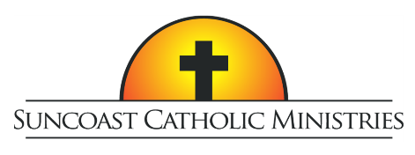
10th Annual
Tampa Bay Men’s Conference

Who Do YOU Say That I Am?

Featuring Dr. Tim Gray and Peter Herbeck

Saturday, February 22, 2020
Higgins Hall at St Lawrence Catholic Church, Tampa
Tickets include lunch and free parking
Tickets are $40 per person with Father/Son combo tickets at two for $40

For tickets or more information visit SuncoastCatholicMinistries.com

