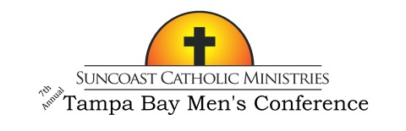

Men: Want to be inspired, reinvigorated, and uplifted?
Does your faith life need a boost?

Then join over a thousand other Catholic men, at all levels of faith,
from parishes throughout the diocese as they gather to revitalize their spirits
at the Suncoast Catholic Ministries 7th Annual Tampa Bay Men’s Conference!

“Living the Faith” The 7th Annual Tampa Bay Men’s Conference
Featuring Dr. Scott Hahn, Fr. Bill Casey and Artie Boyle
with Mass celebrated by Bishop Gregory Parkes
Saturday, February 18th
Higgins Hall at St Lawrence Catholic Church, Tampa
Tickets include lunch and free parking
Cost is $40 per person with Father/Son combo tickets at two for $40
For tickets or more information visit www.suncoastcatholicministries.com
or e-mail info@suncoastcatholicministries.com

