Men: Is life too hectic? Could you use a day to regain balance and perspective?
Experience a new encounter with our Risen Lord. A line-up of dynamic speakers will share insights into living out authentic masculinity and heroic virtue, drawing from their own faith journeys. Mass, Reconciliation, and Benediction will give you the opportunity to reflect on what is going on in your life and how Christ can help.
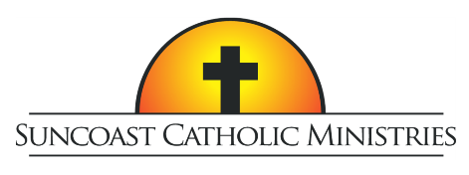
10th Annual
Tampa Bay Men’s Conference

Who Do YOU Say That I Am?

Featuring Dr. Tim Gray and Peter Herbeck

Saturday, February 22, 2020
Higgins Hall at St Lawrence Catholic Church, Tampa
Tickets include lunch and free parking
Tickets are $40 per person with Father/Son combo tickets at two for $40
For tickets or more information visit SuncoastCatholicMinistries.com

