Men: Time and tickets are running out! Don’t miss this opportunity to deepen your faith!
Fathers encourage your sons to go. Sons encourage your dads to go and take you with them. The Conference promises to be challenging, soul-searching, and uplifting – a day that will help you find the peace, order and direction so often missing in life.
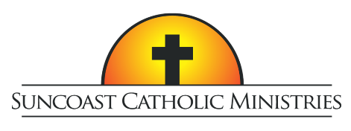
10th Annual
Tampa Bay Men’s Conference

Who Do YOU Say That I Am?

Featuring Dr. Tim Gray and Peter Herbeck

Saturday, February 22, 2020
Higgins Hall at St Lawrence Catholic Church, Tampa
Tickets include lunch and free parking
Tickets are $40 per person with Father/Son combo tickets at two for $40
For tickets or more information visit SuncoastCatholicMinistries.com

