Men: Seize the opportunity, and bring others with you!
As you enter 2020, take the opportunity to learn from others and grow in virtue.
Stand with other men in the battle to reclaim our families and culture for the glory of God! Build stronger friendships by bringing other men with you to share in the experience!
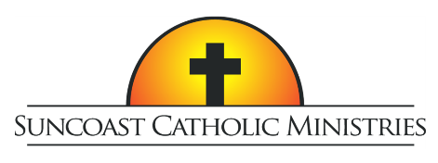
10th Annual
Tampa Bay Men’s Conference

Who Do YOU Say That I Am?

Featuring Dr. Tim Gray and Peter Herbeck

Saturday, February 22, 2020
Higgins Hall at St Lawrence Catholic Church, Tampa
Tickets include lunch and free parking
Tickets are $40 per person with Father/Son combo tickets at two for $40

For tickets or more information visit SuncoastCatholicMinistries.com

